1.get all documents

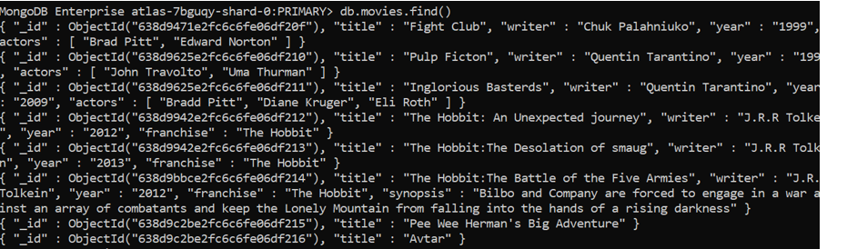

2.Get all documents with writer set to “Quentin Tarantino”

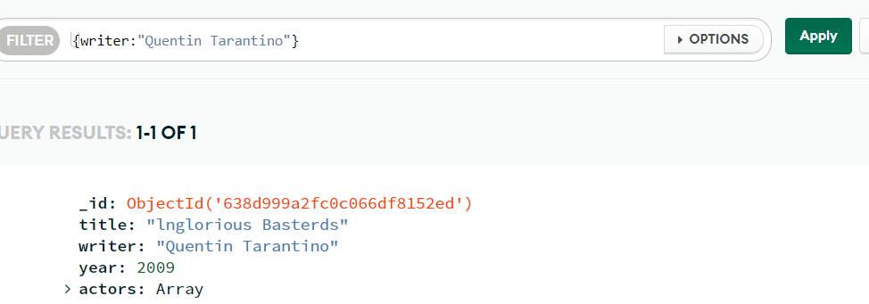

3.get all documents where actors include “Brad Pitt”

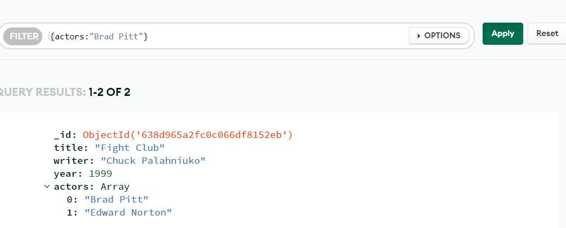

4.get all documents with franchise set to” The Hobbit

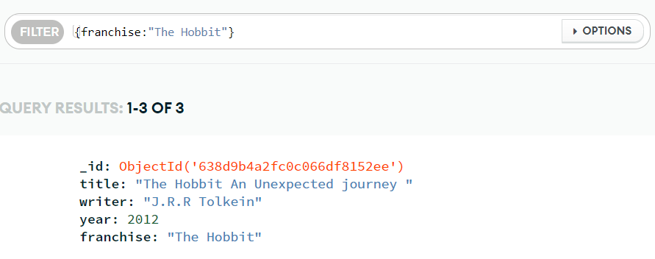5.get all movies released in the 90s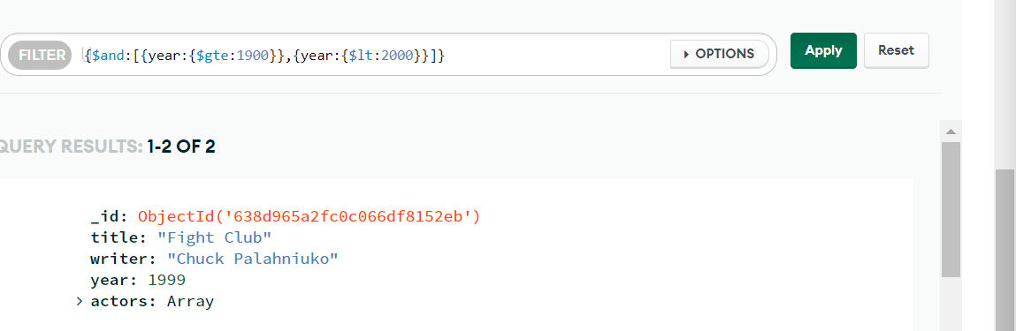

6.get all movies released before the year 2000 or after 2010

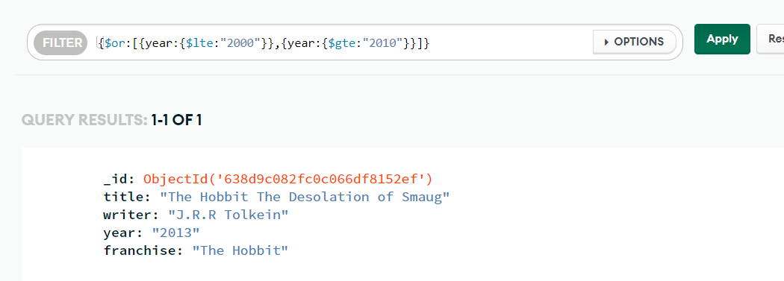

Update document

1.add a synopsis to “The Hobbit:An Unexpected journey “:A relcutant hobbit Bilbo Baggins sets out to the Lonely Mountain with a spirinted group of dwarves to reclaim their mountain home-and the gold within it-form the dragon Smaug”

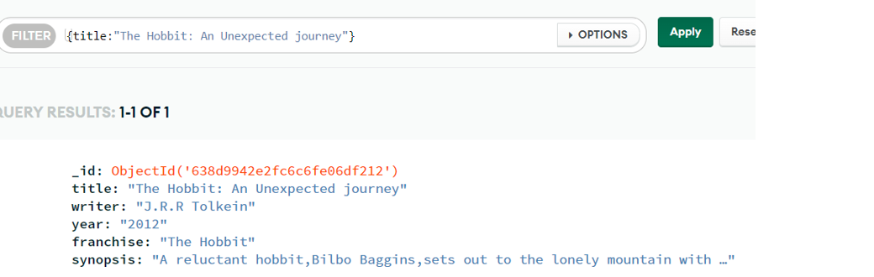

2.add a synopsis to the “The Hobbit:The Desolation of Smaug”:”The dwarves along with Bilbo Baggins and Gandalf the Grey continuen their quest to recailm Erebor their homeland from Smaug Bilbo Baggins is in possession of amysterious and magical ring”

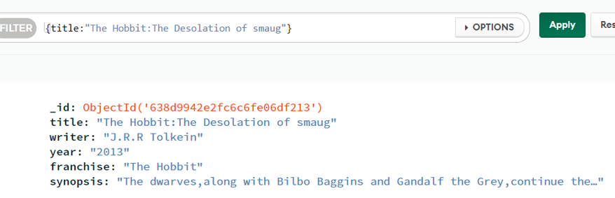

3.add an actor named “Samuel L.Jackson “to the movie “Pulp Fiction”

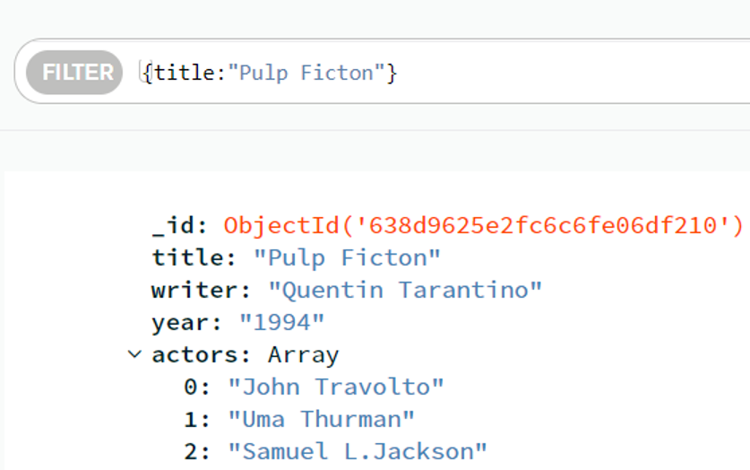

Text Search

1.find all the movies that have a synopsis that contains the word “Bilbo”

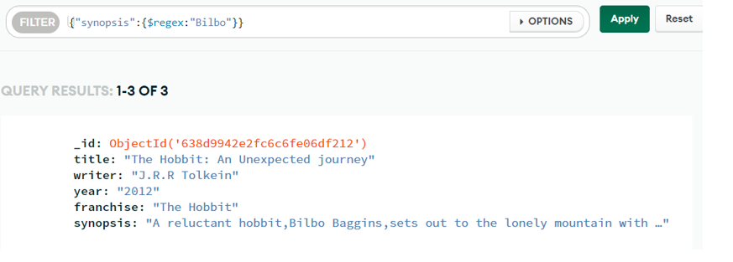

2.find all movies that have a synopsis that contains the word”Gandalf”

